**Instruction on Repository Setup**

1. Create Github account: <https://github.com/> with username (ex: ABC) and email address (ex: ABC1234@xmail.com)
2. Send your user name to ARM code management team
3. After being added as the contributor of certain project, download the local application for MAC or Windows (depending on your computer OS) here: <https://desktop.github.com/>
4. Install Github desktop on your machine. Sign in with your Github account to initialize
5. Click “Add” button on the left up corner, and click “Clone”:

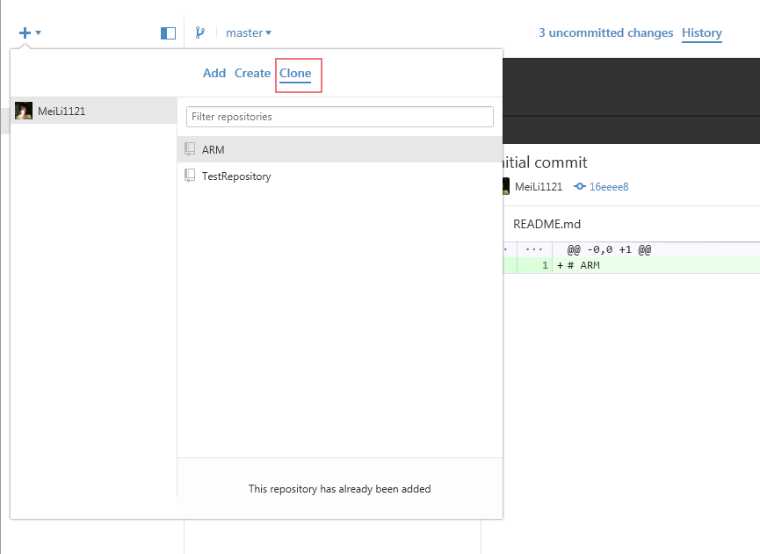

1. If you are added to the code repository, you will see the project name under “Clone”. Select that project and choose where you want the local repository to be, and click “OK”. This will clone the repository from Github to your local drive.

Instruction on how to commit changes:

Once you have cloned the project from Github to your local drive, you can start editing your code on your local machine. Github desktop application will automatically track the difference between your local version of code and the remote code repository. Below is what you will see once you make changes on your local version:

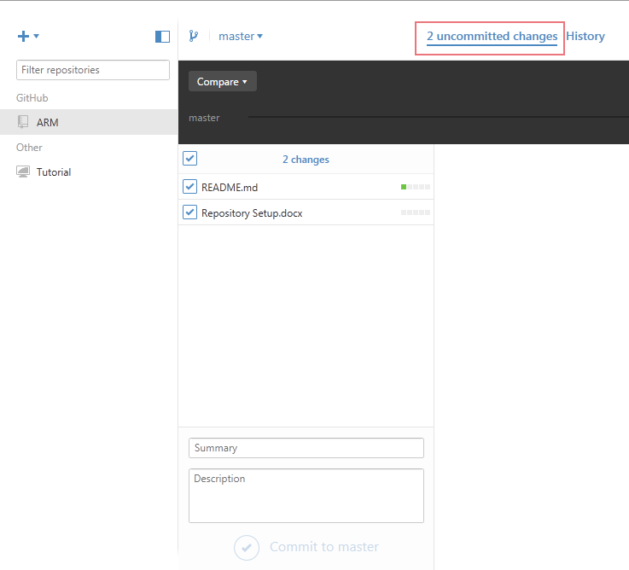

To commit your change, put in your summary and description to help others and yourself keep track of code evolution, and click “Commit to master”. You will see the following screen:

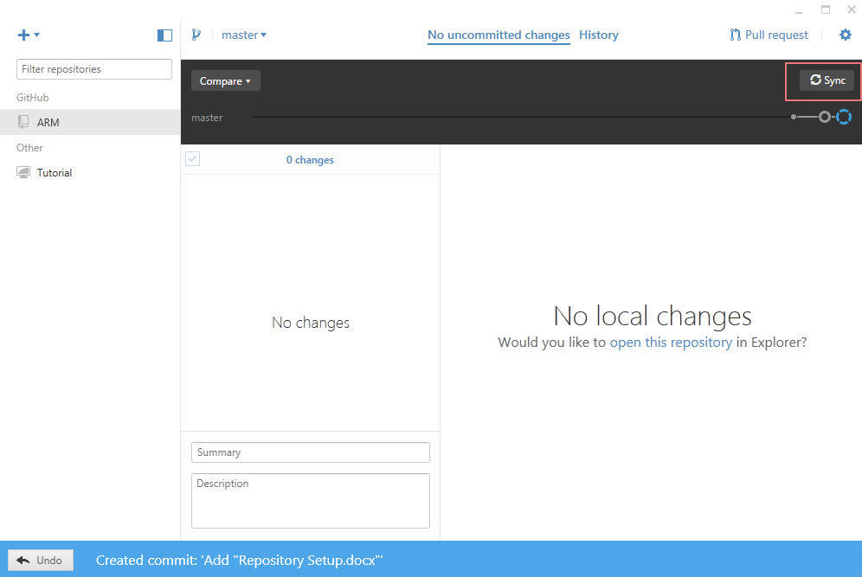

Click the “Sync” button on the up right corner so your change will be synced to Github remote repository, so that other contributors will get your change going forward.